1. The aboveground biomass rate data was from Table 1 (page 36).

NPP was estimated by the peak live standing crop biomass.

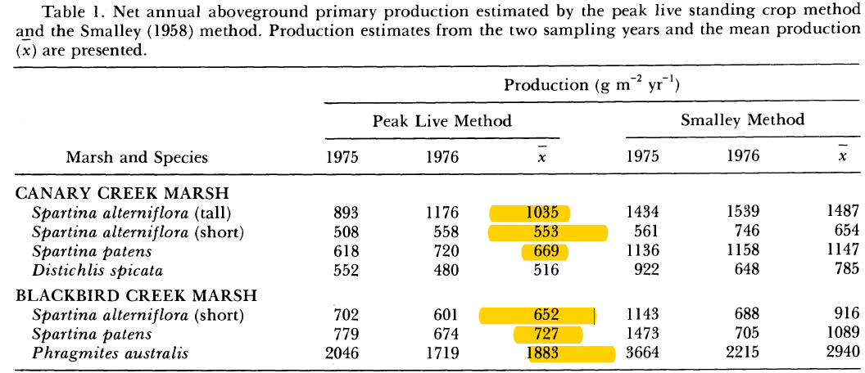

2. We have max and min data for belowground biomass on the master datasheet, however the AVG columns were empty. We used the AVG data from max and min from Table 4 (page 39) to calculated annual mean belowground biomass.

All the raw data was entered in the spreadsheet “91-Biomass Stock Calculations.xlsx”, and was calculated by SAS codes.

